V.Postharvest Unlimited Conference 10-13 June 2014,

Step 1. Go to our web site cyprusair.com

Step 2. click on conference code
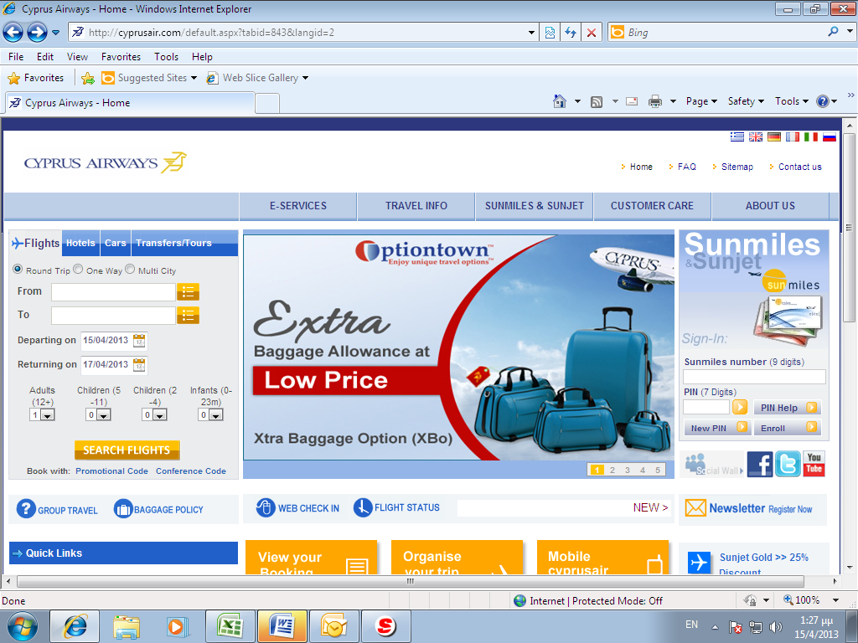

Step3. click on Purchase tickets
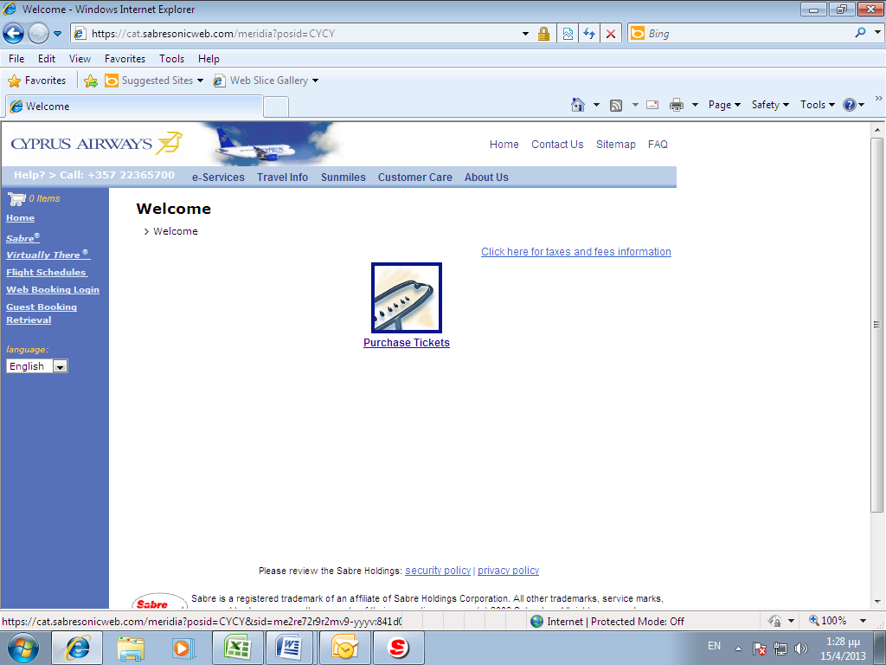

Step 4. Fill with the necessary information.
It is important to put the code for the Coupon Number passenger 1 which is B2FW7QE and Promo Conference Code CYX11
